

**Develop an energy storage deployment strategy for new offshore wind farms in the United States**

**The Challenge:**

Create a fictional case study for an offshore wind farm and energy storage system in the northeast United States. Propose an energy storage utilization strategy for this case study. Develop a financial and operation model that optimizes the utilization of energy storage with offshore wind production for this case study.

**About this Challenge:**

The offshore wind market in the United States is growing at a rapid rate, with over 1,400MW of offshore wind capacity awarded this year alone in Massachusetts, Connecticut, and Rhode Island (vs. 30 MW operating in 2017). As of June 2018, there was ~25.5 GW of offshore wind in U.S. project development pipelines. As this emerging market continues to grow, stakeholders are also becoming increasingly interested in the potential benefits that could arise from integrating energy storage into an offshore wind farm. Under the proper utilization model, energy storage with offshore wind could potentially improve project economics and provide additional power grid benefits.

**Challenge Goals:**

Develop a proposal for using energy storage alongside an offshore wind farm in any state along the U.S. east coast. In doing so, your proposal should include the following items:

* The location and size of the offshore wind farm, including cost estimates.
* The size (MW/MWh) and technology type (lithium-ion, flow batteries, mechanical, etc) of the energy storage system, including cost estimates.
* The proposed energy storage utilization strategy, including any value or revenue streams that are to be stacked.
* A mock financial and operational model of storage and offshore wind production. You may include several scenarios if desired.
* List of any assumptions and cite resources utilized in developing the model.

We will provide you a spread sheet with mock hourly wholesale power prices for a year. In addition, we will provide a net capacity factor production curve for an offshore wind farm, an onshore wind farm, and a solar farm. You will be allowed to use this data to build your team’s case for a given offshore-battery strategy. You may also utilize market data from ISOs (ISO-NE, NYISO, PJM) if you wish to do so.

When developing your case study and storage strategy, consider the following questions:

1. What is the optimal battery size when co-located with an offshore wind farm and what are the key trigger points?

2. What is the preferred technology (quick charge/dis-charge vs. large capacity) considering the revenue potential?

**Background:**

On 10/08/2018, the Special Report from UN Intergovernmental Panel on Climate Change (UN IPCC) highlighted that society has until 2030 to mitigate global warming and keep temperature rises to a maximum of 1.5ºC. CO2 emissions will need to fall 45% from 2010 levels by 2030 to reach "net zero" by 2050. 1 Meeting this goal demands extraordinary transitions in energy, land, transportation and infrastructure.

Significant carbon emission reductions in the U.S. early on will be achieved through the rapid decarbonization of the power sector. The U.S. electric power sector has already begun this low carbon transformation, reducing annual carbon emissions levels by over 300 million metric tons of CO2 in 2017 compared to emission levels of five years prior (-14% vs. 2013).2 Driving these U.S. CO2 emission reductions is the shift in generation mix from coal and oil-based power to combined cycle natural gas plants and renewable power sources like wind and solar PV. However, to meet national and state-level carbon emission abatement goals the power sector will need to rapidly deploy more zero-carbon energy technologies while simultaneously ensuring that the grid maintains reliable and low cost electricity.

Enabling the rapid deployment of clean energy technologies is the increase in performance and cost competitiveness of renewable energy technologies like solar PV, onshore wind, and offshore wind. According to a 2017 International Renewable Energy Agency (IRENA) report, the U.S. average levelized cost of electricity (LCOE) for onshore wind and utility-scale solar PV has fallen by as much as -80% and -40%, respectively, since 2010. 3 As a result, solar PV and onshore wind farms in certain areas of the U.S. are more cost competitive than traditional thermal generation sources like coal and natural gas. Offshore wind -- while in its nascent stages in the U.S. – has also experienced significant cost reductions, primarily due to technology and construction improvements made in the more mature offshore wind market in Europe.

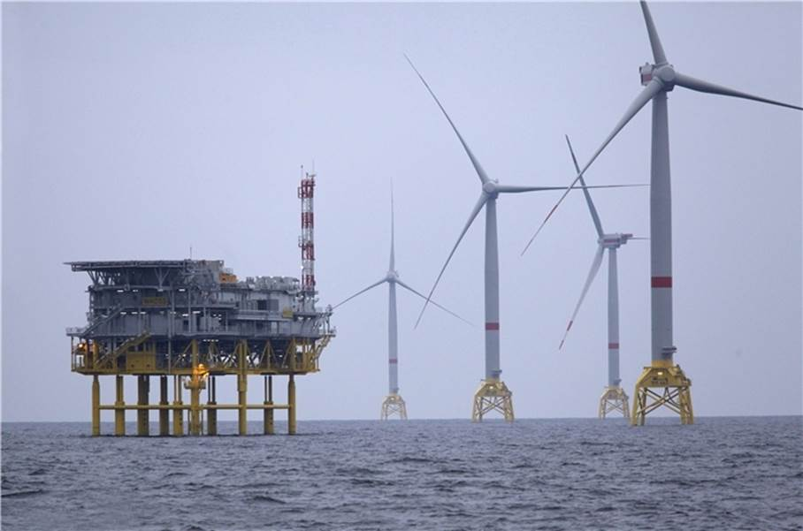

**Figure 1**: Offshore Wind Farm

With competitive prices driving higher demand for renewable technologies, offshore wind has become an emerging market for states off the U.S coast. Offshore wind farms have the added benefit of being able to be located directly next to coastal cities with high electricity demand, eliminating the need to procure land or transmission lines that may be difficult to acquire. Additionally, the technology has larger capacity factors than onshore wind farms or solar farms, allowing the offshore wind farm to provide more constant power to a coast city or state. In addition to the benefits of emissions free energy, adding an offshore wind farm could bring millions in economic benefits to states through new jobs and investment. 4

Eastern U.S. states today are actively seeking proposals for new offshore wind farms and have already made large commitments to the technology. Today, there is only 30MW of U.S. offshore wind capacity being operated (Rhode Island). Yet, in 2018 alone Massachusetts, Connecticut, and Rhode Island selected bidders to construct 1,400 MW of offshore wind capacity. Vineyard wind – a joint venture between Avangrid Renewables and Copenhagen Infrastructure Partners – will be an 800 MW wind farm built off the coast of Massachusetts, and when operating in 2021, will be the largest offshore wind farm in the U.S. The interest in offshore wind is expected to continue, with Massachusetts, New Jersey, and New York already setting state offshore wind capacity targets totaling up to 7,500 MW. A full overview of offshore wind targets and projects can be found in Figure 2 below (courtesy of S&P Global). 5

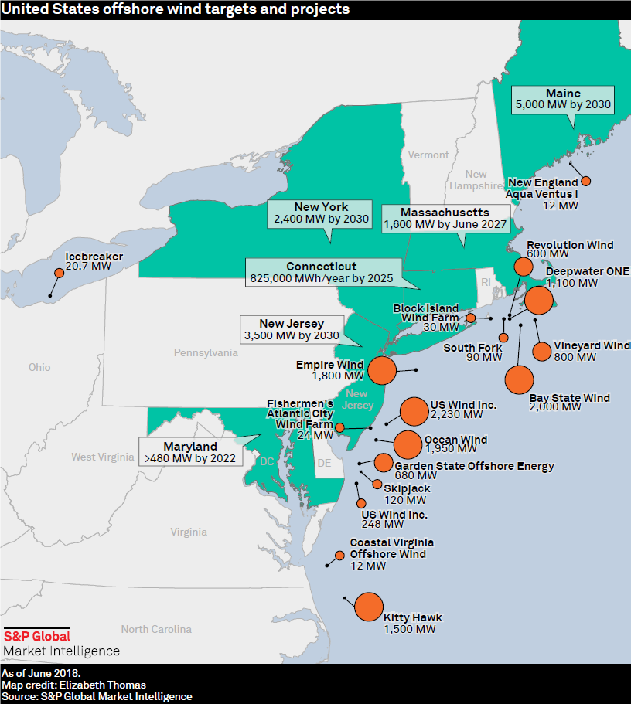

**Figure 2**: S&P Global overview of U.S. offshore wind targets and leases.

Developing concurrently with the emerging offshore wind market is the demand for energy storage devices to be coupled with new renewable generation assets. Power generation from renewable technologies is driven by weather patterns, and as result power is generated intermittently on hour by hour basis. At low levels of penetration, variable and uncertain power output from renewable power sources is not a serious issue to the power grid since the grid is designed to accommodate the uncertainty of load and contingencies of outages. However, at higher levels of renewable penetration the effects of intermittency may lead to challenges in grid operation and an increase in the curtailment of low-cost wind energy. Energy storage devices hold the potential to eliminate these concerns in a manner that provides benefits to both the grid and the renewable energy operator.

The value of energy storage is spatially and temporally dependent, making it more difficult to develop a “plug and play” business model for the technology. Energy companies have developed utility-scale energy storage to provide services directly to the grid (Front-of-the-meter) while some industrial and municipal customers have placed the storage behind their electricity meters (Behind-the-meter) to optimize energy consumption and energy savings. For renewables integration, the industry has considered many different applications for storage including using storage to address short-duration power variability (seconds to minutes) and long-duration power variability (intra-day, day-to-day, seasonal).

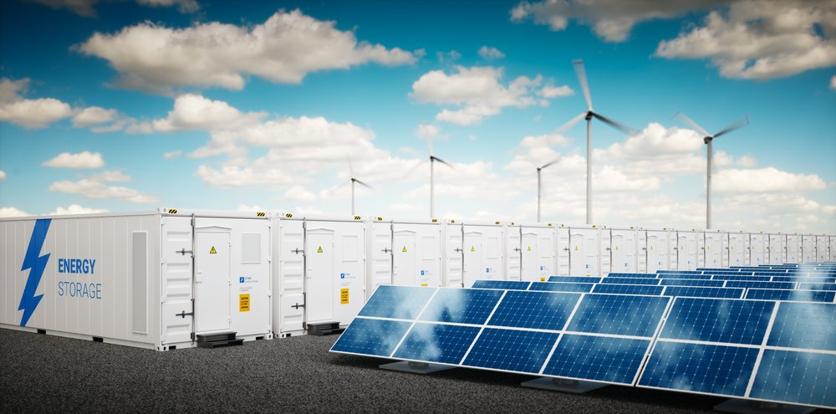

**Figure 3**: Energy Storage integrated with renewable technologies

The benefits of coupling energy storage with onshore wind and solar PV has been studied intensively by industry and academia over the last few years, yet to date there has been less work done on coupling energy storage with offshore wind power. It was only in June 2018 that Equinor (now Statoil) announced it had deployed the world’s first offshore wind battery. 6 The concept itself is similar to coupling storage to onshore wind power, but the size, power capacity, and geographic location of offshore wind technology makes the coupling a different task.

**Suggested Resources:**

* Brattle, Comprehensively Valuing Battery Storage in California

<http://files.brattle.com/system/publications/pdfs/000/005/494/original/stacked_benefits_-_final_report.pdf?1505226490>

* Deloitte, Energy Storage: Tracking the technologies that will transform the power sector<https://www2.deloitte.com/content/dam/Deloitte/us/Documents/energy-resources/us-er-energy-storage-tracking-technologies-transform-power-sector.pdf>
* GE, GE’s Reservoir Solutions <https://www.ge.com/renewableenergy/hybrid/battery-energy-storage>
* GTM, Is Offshore Wind a Better Deal With Batteries? <https://www.greentechmedia.com/articles/read/is-offshore-wind-a-better-deal-with-batteries#gs.9dI3YGs>
* IRENA, Renewable Power Generation Costs in 2017 [www.irena.org/-/media/Files/IRENA/Agency/Publication/2018/Jan/IRENA_2017_Power_Costs_2018.pdf](http://www.irena.org/-/media/Files/IRENA/Agency/Publication/2018/Jan/IRENA_2017_Power_Costs_2018.pdf)
* IRENA, Electricity Storage and Renewables: Costs and Markets to 2030 <http://www.irena.org/-/media/Files/IRENA/Agency/Publication/2017/Oct/IRENA_Electricity_Storage_Costs_2017.pdf>
* L A Z A R D ’ S L E V E L I Z E D C O S T O F E N E R G Y A N A LY S I S — V E R S I O N 11 . 0 <https://www.lazard.com/media/450337/lazard-levelized-cost-of-energy-version-110.pdf>
* 2017 U.S. Department of Energy Offshore Wind Technologies Market Update <https://www.energy.gov/sites/prod/files/2018/09/f55/71709_V4.pdf>

**Citations:**

1. “Global Warming of 1.5°C.” *IPCC.ch*, Intergovernmental Panel on Climate Change, 8 Oct. 2018, www.ipcc.ch/report/sr15/.
2. “Electric Power Annual 2017.” Eia.gov, U.S. Energy Information Administration, 22 Oct. 2018, [www.eia.gov/electricity/annual/](http://www.eia.gov/electricity/annual/).
3. “Renewable Power Generation Costs in 2017.” *Irena.org*, International Renewable Energy Agency, [www.irena.org/-/media/Files/IRENA/Agency/Publication/2018/Jan/IRENA_2017_Power_Costs_2018.pdf](http://www.irena.org/-/media/Files/IRENA/Agency/Publication/2018/Jan/IRENA_2017_Power_Costs_2018.pdf).
4. “Offshore Wind: Generating Economic Benefits on the East Coast.” *Www.e2.Org*, E2, 2018, [www.e2.org/wp-content/uploads/2018/08/E2-OCS-Report-Final-8.30.18.pdf](http://www.e2.org/wp-content/uploads/2018/08/E2-OCS-Report-Final-8.30.18.pdf).
5. “Offshore Wind Ready To Take Off In The United States.” *Offshore Wind Ready To Take Off In The United States | S&P Global Market Intelligence*, S&P Global Market Intelligence, 2018, [www.spglobal.com/marketintelligence/en/news-insights/research/offshore-wind-ready-to-take-off-in-the-united-states](http://www.spglobal.com/marketintelligence/en/news-insights/research/offshore-wind-ready-to-take-off-in-the-united-states)
6. “World's First Offshore Wind Battery Now Installed.” *Offshorewind.biz*, 2018, [www.offshorewind.biz/2018/06/27/worlds-first-offshore-wind-battery-now-installed/](http://www.offshorewind.biz/2018/06/27/worlds-first-offshore-wind-battery-now-installed/).